# Testing Instructions for the MCBCom board

## 1. Power device

Set a power supply to 12V and limit its output current to about 100mA

Connect the board as shown in picture and make sure the power supply doesn’t show a short circuit.

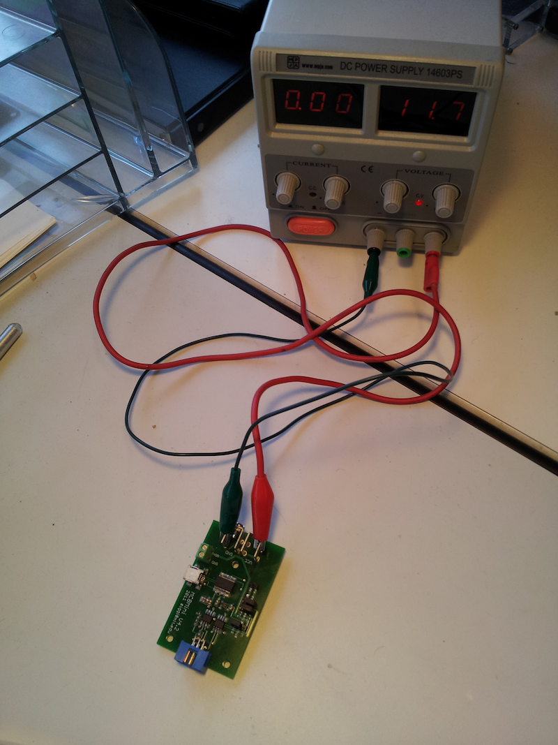

Make sure that the jumper caps are in this following setting:

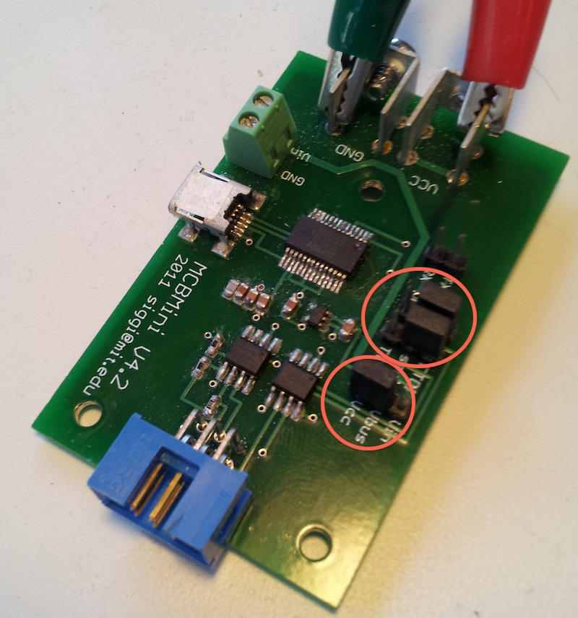

## 2. USB Connectivity

Connect a USB between the computer and the board

Windows should either find the drivers for this board automatically or you can download them from here: <http://www.ftdichip.com/Drivers/VCP.htm>

Once the drivers have been installed (automatically or manually), you should look at the “Device Manager” (right click on My Computer and go to Properties->Device Manager) and it should have a USB Serial Port as is displayed in the following picture:

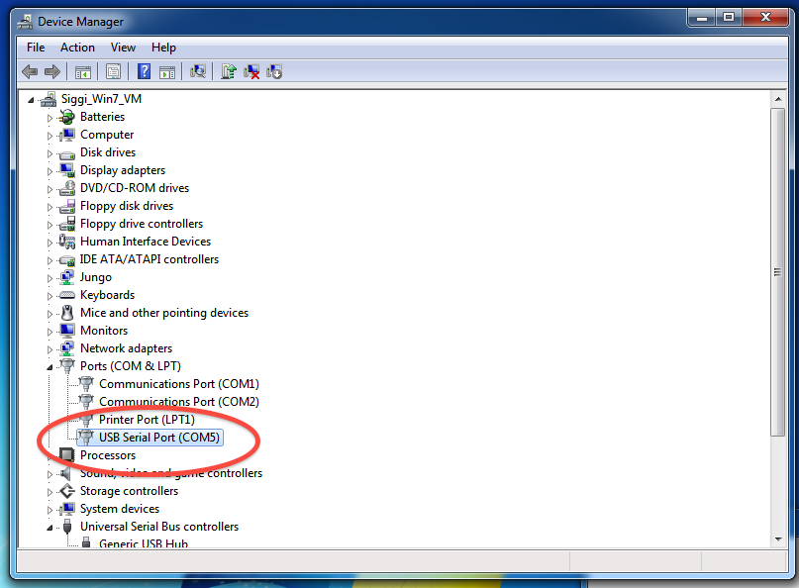

Notice the COM port name (it is COM5 in the picture) because you will have to use it when communicating with the boards.

## 3. Install Java

To test to see if java is currently working on your system then open a Command Line (Start->Run-cmd [Enter]). From the CMD prompt type “java”, if it says “Command not found” or something similar then you either don’t have java installed OR the system PATH variable doesn’t point to where Java is installed.

Help on setting the system PATH variable properly can be found here:

<http://java.com/en/download/help/path.xml>

If Java isn’t currently installed on your system, download it from here and install it:

<http://www.java.com/en/download/index.jsp>

## 4. Test Communications

Connect a working MCBMini board to the MCBCom board as shown in picture, make sure that the ribbon cable connector has the proper orientation (same side up in both connectors)

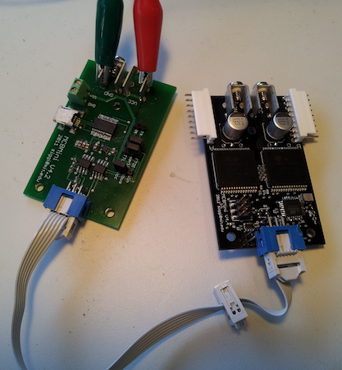

Unzip the **TestSuite.zip** into a convenient folder location such as C:\TestSuite

Open up the Atmel CMD prompt (Start->Atmel->Atmel CMD Prompt) and move to the test directory:

“cd C:\TestSuite”

Run the communications test with the proper name of the COM port:

“communications_test.bat NAME_OF_COM_PORT”

Here is the expected output of a successful run

12:26:55-MCBMini: MCBMini: Parsing configuration file "motor_config.xml" of version: 1.1

12:26:55-MCBMini: Waiting for all boards to report their firmware, IDs: 1:

12:26:56-MCBMini: Motorboard 1 reports firmware version: 30

12:26:56-MCBMini: All boards have reported their firmware, lowest firmware version: 30

SUCCESS !! Firmware value: 30

If the process fails then you will see “FAILIURE” in the output.

# Congratulations! You seem to have a working MCBCom board !!